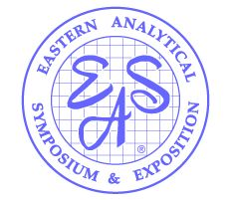
2022 EAS Short Course Proposal
Crowne Plaza, Princeton, November 13 – 16, 2022
Please return before March 1, 2022 to
askeas@eas.org

Your Name, Title:
Company/Institute:
Address:
Telephone:
Email:

Do you have a co-instructor? _______ Yes _______ No
EAS has a max of 2 instructors per course.
Please provide co-author, name, affiliation, email, mailing address, and biography below.
Co-Instructor Name:
Company/Institute:
Address:
Telephone:
Email:

Length of Course: ___________ 1-day ___________ 2-day
(EAS does NOT offer half-day courses during the symposium)

Although we are hopeful that we will be able to have an in-person meeting, if the pandemic doesn’t allow for it, we have every intention to have a virtual EAS.
In the event we have a virtual EAS, are you willing to give your short course virtually via Zoom? _______ Yes _______ No

Also, EAS is anticipating hosting online, abbreviated short courses in addition to the in-person courses at the November meeting.

Would you be interested in giving your short course virtually?
_______ Yes _______ No

If yes, what format would you prefer (options below are for survey purposes only):
___________ half-day (3-4 hrs.)
___________ “1-day” (8 hrs. split over 2 days)

COURSE TITLE:

COURSE DESCRIPTION (100 words or less):

WHO SHOULD ATTEND (100 words or less):

TOPICS (SAMPLE OUTLINE):

INSTRUCTOR(S) BIOGRAPHIES (brief overview):

Do you anticipate any special equipment requirements?

