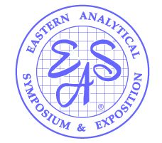
2026 EAS Short Course Proposal
Crowne Plaza, Princeton, November 15 – 18, 2026
Please return before Wednesday, February 16, 2026 to
askeas@eas.org

Your Name, Title:
Company/Institute:
Address:
Telephone:
Email:

Do you have a co-instructor? _______ Yes _______ No
EAS has a maximum of 2 instructors per course.
Please provide co-author, name, affiliation, email, mailing address, and biography below.
Co-Instructor Name:
Company/Institute:
Address:
Telephone:
Email:

Length of Course: ___________ 1-day ___________ 2-day _______ half-day
(EAS is considering offering half-day courses during the symposium in Nov.)

COURSE TITLE:

COURSE DESCRIPTION (100 words or less):

WHO SHOULD ATTEND (100 words or less):

TOPICS (SAMPLE OUTLINE):

INSTRUCTOR(S) BIOGRAPHIES (brief overview):

Do you anticipate any special equipment requirements?

